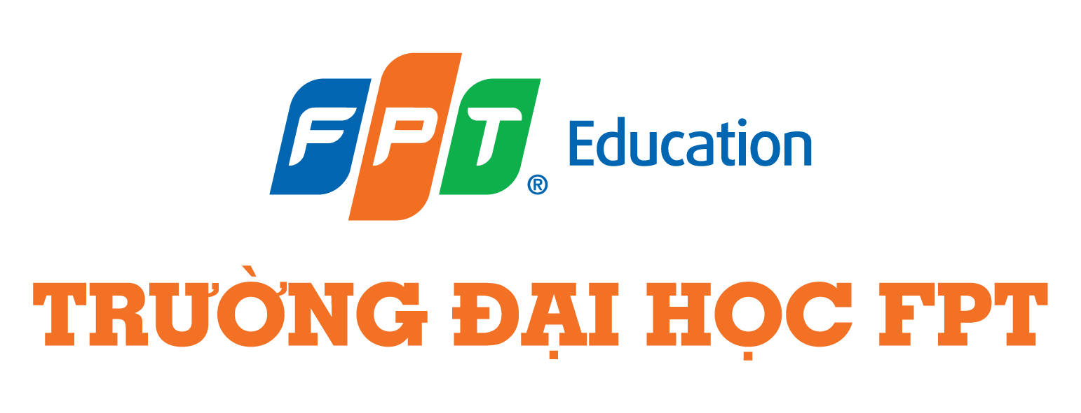
Case 2 Week 7
Case Name: More than just LEGO
Background Information Watch: https://youtu.be/lOdcAdqGFnM?feature=shared
Company: LEGO
Founder: Ole Kirk Christiansen
Introduction: “The LEGO Group is a privately held company based in Billund, Denmark. The company is still owned by the Kirk Kristiansen family who founded it in 1932.” (LEGO, 2024)
Issue: LEGO is famous for its brick type assembly which has been a staple in many households all around the world. Its path to growth was not just about selling toys, it was about content such as movies, TV shows, and licensing its IP. The business model of Lego is worth a closer look for those looking for inspiration. (LEGO, 2024)
References
The Wall Street Journal, (2023) Why Lego Isn’t (Just) a Toy Company | WSJ The Economics Of, Available at <https://youtu.be/lOdcAdqGFnM?feature=shared>
LEGO, (2024) The LEGO Brand, Available at <https://www.lego.com/en-us/aboutus/lego-group/the-lego-brand>

